**Module mining**

**Pre-processing**

**Population RNASeq**

**GSE48865**

**Single-Cell RNASeq**

**GSE57872**

**Module mining**

**Construct co-expression networks**

MGH31

(TPM)

MGH28

(TPM)

MGH30

(TPM)

MGH26

(TPM)

MGH29

(TPM)

Single-Cell (TPM)

Population

(TPM)

**Partition by tumor**

equal densities

**Compare**

**Construct co-expression network**

**Construct summary network**

|  |  |  |  |  |
| --- | --- | --- | --- | --- |
| MGH30 | | | | |
|  | gene1 | gene2 | gene3 | … |
| gene1 | 1 |  |  |  |
| gene2 |  | 1 |  |  |
| gene3 |  |  | 1 |  |
| … |  |  |  |  |

|  |  |  |  |  |
| --- | --- | --- | --- | --- |
| MGH31 | | | | |
|  | gene1 | gene2 | gene3 | … |
| gene1 | 1 |  |  |  |
| gene2 |  | 1 |  |  |
| gene3 |  |  | 1 |  |
| … |  |  |  |  |

|  |  |  |  |  |
| --- | --- | --- | --- | --- |
| MGH29 | | | | |
|  | gene1 | gene2 | gene3 | … |
| gene1 | 1 |  |  |  |
| gene2 |  | 1 |  |  |
| gene3 |  |  | 1 |  |
| … |  |  |  |  |

|  |  |  |  |  |
| --- | --- | --- | --- | --- |
| MGH28 | | | | |
|  | gene1 | gene2 | gene3 | … |
| gene1 | 1 |  |  |  |
| gene2 |  | 1 |  |  |
| gene3 |  |  | 1 |  |
| … |  |  |  |  |

|  |  |  |  |  |
| --- | --- | --- | --- | --- |
| MGH26 | | | | |
|  | gene1 | gene2 | gene3 | … |
| gene1 | 1 |  |  |  |
| gene2 |  | 1 |  |  |
| gene3 |  |  | 1 |  |
| … |  |  |  |  |

Modules

Summary Network

MGH26

MGH28

MGH29

MGH31

MGH30

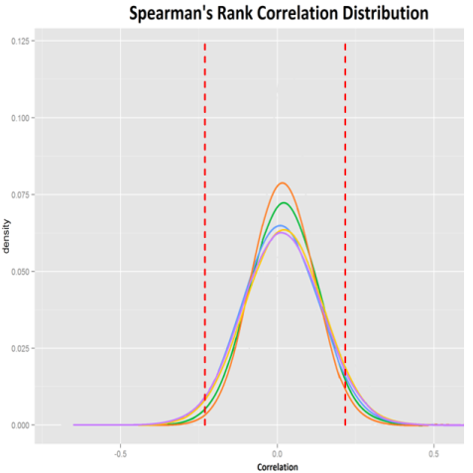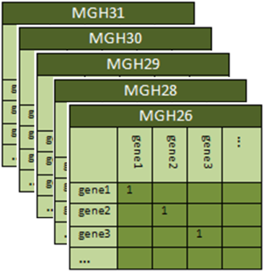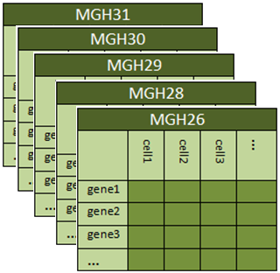

Feedback

Threshold Correlation

Visualize

Correlation Matrices

Single Cell Datasets

Modules

Threshold Support

CODENSE Algorithm

Summary Network

MGH26

MGH28

MGH31

MGH30

MGH29

Spearman’s Correlation